|  |
| --- |
| Education Reform |
|  |

|  |  |
| --- | --- |
| 08-Aug-19 | Saasha Mor |

A project proposal on ways we make the education system in India better.

Find the prototype [here](https://xd.adobe.com/view/19b9bdae-d7f3-458a-4819-8cd2e15f5526-6f88/)

INDEX

Why do we need to fix the education system? 2

Stakeholders 2

Direct Stakeholders 2

Indirect Stakeholders 3

Problems outlined by stakeholders 3

Students and Parents 3

Potential Employers 4

personas 5

research on learning and teaching methods 7

Setting goals and expectations 7

Connecting new information to prior knowledge 8

Environment matters 9

Communication and Mental Health 9

Approaches 11

What can we do? 15

The online platform – prototype 17

Case study – online education platforms 23

CONCLUSION 27

FAQ 28

Bibliography 29

Appendices 30

Education Reform

Saasha Mor

# Why do we need to fix the education system?

Humans are on the top of the food chain for a reason – we are smart creatures. We spend our lives trying to learn about the universe around us. Learning is an integral part of our lives, but the system that is charged with the responsibility to deliver this information is problematic in many ways. For starters the Central Board of Secondary Education has had very minimal change in curriculum since 1962. Additionally, school teaching and learning practices have deteriorated throughout the years without any meaningful initiatives for change.

This phase of children’s lives is the steppingstone that molds the people they become which is why I am committed to change it to the best possible version.

# Stakeholders

## Direct Stakeholders

* Students
* Parents
* Educators

These are the direct stakeholders since they directly interact with the education system in India and are the most affected by its shortcomings.

I gathered this information by having prior knowledge as a current student. Through a feedback form (statistics in appendix) I investigated the main problem areas and expectations the stakeholders have from the education system in India.

## Indirect Stakeholders

* Potential employers
* Industry and Society

Indirect stakeholders are those who may not directly interact with the education system in place but are nevertheless affected by it. These are mainly elements that are affected by the degradation or flourishing of the direct stakeholders.

# Problems outlined by stakeholders

### Students and Parents

The results from the feedback form yielded the following results:

Elements that detracted from the learning process:

* Ineffective teaching methods
* Textbooks focus just on theory
* Not enough practical and real-world connection
* Emphasis on rote learning
* Too much priority on grades
* Not recognizing the anxiety and stress caused
* Having to take outside help – online or paid tuitions

Elements that contributed to the learning process

* Online videos that give practical applications to the theory
* Relevant worksheets, examples and project work
* Concise notes
* One on one help
* Self-paced work
* Extra-curricular activities

### Potential Employers

*\*\* It should be noted that a very small number of potential employers filled the form and thus might have inaccurate results.*

The results from the feedback form yielded the following results:

Qualities that recruiters look for in students

* Professionalism and work ethic
* Common sense
* Practical knowledge
* Someone who can take up the responsibilities required for the job, professionalism, technical ability
* Subject knowledge

Qualities students lack in the workforce

* Body language, speaking and presentation skills
* Core skills
* Subject matter knowledge n practical experience
* Passion for the job (only care about pay), barely any job experience
* Practical experience

Skills students should have before hand

* How to carry themselves
* Skills in sync with their abilities and education
* Supply chain basics
* Work experience
* Basic hands on experience of the subject matter

# personas

# 

# 

# 

# 

# research on learning and teaching methods

Based on research into scholarly articles on learning and teaching methods, I have determined some elements that are important for the education system which have been outlined below.

## Setting goals and expectations

One of the major causes of poor approaches to learning be students is the lack of information about the expectations from them and the goals of the learning material. According to Michael Prosser and Keith Trigwell in their book called Understanding Learning and Teaching: The Experience in Higher Education: (Prosser & Trigwell, 1999)

“Teachers first need to determine students’ perceptions of the assessment, their workload, the clarity of goals and standards, the teaching they receive and the learning choices they receive. Differences in in these perceptions may relate to the differences in approaches to learning” (Prosser & Trigwell, 1999)

## Connecting new information to prior knowledge

Everyone has prior experiences and knowledge which helps in making sense of new information received. For example, we learn to walk at a very young age, but when we study the concept of gravity and forces, we understand why things don’t float off the ground. According to Prosser and Trigwell, there is a dualistic perspective the student and the world around them, it is the educator’s job to bridge that gap with the education they impart. (Prosser & Trigwell, 1999)

“The basic idea is that in any act of learning, students simultaneously engage in three successive stages- acquiring, knowing and applying” (Prosser & Trigwell, 1999)

Additionally, students should be taught on learning methods. This entails figuring out what they have not been able to succeed in, why and how to excel at the material.

## Environment matters

Author of the book *The Poetics of Space*, Gaston Bachelard, describes the importance of the environment we are in to motivate “daydreaming” and an infinite world of possibilities. Big companies that rely on the innovation and creativity of their employees like Amazon also creates spaces that foster creativity. (Bachelard, 1957) For example, Amazon spheres has glass infrastructure with offices that have plenty of natural sunlight, nature and panoramic views. It also makes work a “fun” place that reduces stress and monotony. It is a mystery to me why schools don’t facilitate the same environment when it is a powerhouse of the most innovative minds.

A January 2016 study by researchers at the University of Illinois at Urbana-Champaign Department of Landscape Architecture identified that windowless classrooms are linked to lower test scores for high school students. (Jodi Heckel, 2016)

## Communication and Mental Health

There is a stigma in education systems that students with poor grades are just bad students. We must change the conversation about pestering kids for good grades and create an environment that actually helps them. This requires investigating why a student is not able to succeed using a four-component model. A student must possess four things to be successful - paying attention, ability, effort, and organization. (Naparstek, 2002) Sometimes failure to do these things might be because of the following reasons:

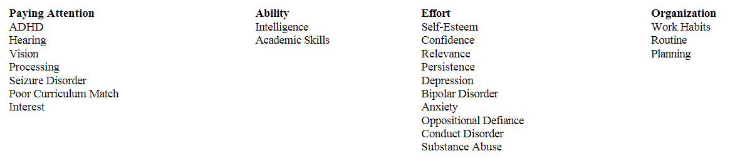

Thus, teachers should be trained in recognizing the presence of mental health issues and how to identify them. However, the educator is NOT expected to give a formal diagnosis, just an informal one that gets the student the help they need, possibly with a psychologist.

However, mental health is not all about the disorders that are associated with it. It also entails mental well being with respect to the education system. Additionally, school is where a student spends most of their time, so the system is responsible for their physical and mental wellbeing. Mental wellbeing has known to be correlated with grades but can entail several things for example:

* Bullying
* Substance abuse
* Eating disorders
* Adolescent sexuality
* Concerns among LGBTQ youth
* Family adjustment and adjustment issues
* Interpersonal Violence (dating and sexual violence)
* Childhood traumatic event experiences

Additionally, Companies are now scouting for people who are compassionate, reliable on the job, productive team workers, and care both about their coworkers and their job (i.e., emotionally intelligent individuals). (Zeidner, 2009)

## Approaches

I would encourage teachers to explore new research in teaching methods to find what works for them and their students. I will discuss two simple, broad scope teaching methods.

### Project WET Foundation

Many versions of the learning cycle have four steps (Fig. 2.2). These steps can be identified in most popular environmental education activities like Project WET’s Activity Guide (Project WET Foundation, 2011). Many activities follow the steps in order, which helps educators ensure they include each step.

* *Introducing* the lesson and activating the appropriate memories
* The first step is *the experience*, while the following three steps are strategies to help learners reflect on and accommodate the information.
* Step 2 *emphasizes processing.* Questions about what happened, what data were collected, and what was observed help learners pull the experience into their mental framework.
* The next step involves *generalizing the information* from the experience. Learners might hypothesize why one group’s responses were different from their own. Worksheets and journals are two strategies that help educators guide learners through these two stages by reporting their findings, *comparing and contrasting*, and making sense of their experiences and feelings.
* Finally, the fourth step makes the concept more usable and flexible in learners’ mental models. Learners are asked to *apply the concept* to a new situation

### The 5E instructional model

A five-step learning cycle developed by Bob Karplus at the University of California Berkeley with Myron Atkin at the University of Illinois was adapted by science educators at BSCS (Biological Sciences Curriculum Study) in Colorado and used extensively in their research and educational materials. *Engage.* Learners are introduced to the task and prior knowledge is accessed. Motivating questions and problems are often used to spark curiosity and discussion. (Bybee, et al., The BSCS 5E Instructional model: Origins and effectiveness.)

* *Explore.* Learners are directly involved in activities, field observations, data manipulation, or other experiences to create a common base of experience for the current concepts. Questions and interaction with others help them build understanding about the new information.
* *Explain.* An instructor provides information about the concepts through lecture, readings, and discussion. Learners demonstrate their understanding, skills and behaviors. Abstract concepts are introduced and explained.
* *Elaborate.* Instructors challenge and extend understanding. Learners apply concepts in a new situation, testing patterns and ideas and verifying their understanding.
* *Evaluate.* Instructors employ assessment techniques to monitor and quantify learners’ progress. Learners assess their own understanding and abilities.

### Constructivism

A relatively new and important concept in education is constructivism, which became popular in the last two decades of the 20th century. This theory acknowledges the role that experience, and reflection have in the learning process, but explains that people construct their own understanding from those experiences. (Boudourides, 2003).

“A view of science that acknowledges an external and knowable world but depends critically on an intellectually demanding struggle to construct heuristically powerful explanations through extended periods of interaction with objects, events, and other people. . .. We believe that human beings are meaning-makers; that the goal of education is to construct shared meanings and that this goal may be facilitated through the active intervention of well-prepared teachers” (Mintzes, Wandersee, & Novak, 2005)

Five guiding principles of constructivism are helpful for educators of both young people and adults (Brooks & Brooks, 1993)

* *Posing problems of emerging relevance to learners*. If learners do not find the topic inherently interesting, an educator must find a way to make it meaningful. Prompting questions, changing perspective, asking for a testable prediction, and offering immediate feedback are some suggested strategies for increasing relevance.
* *Structuring learning around primary concepts.* Constructivist teachers organize their teaching around major themes or essences. If these themes are problems, they engage learners in solving them. By relying on the major theme to connect the lessons, they focus on the whole, the system. It is much easier to break concepts into understandable pieces than to assemble the pieces into a whole system.
* *Seeking and valuing students’ points of view.* Understanding learners’ perspectives enables educators to challenge learners, reframe questions, and make information meaningful. It takes time to understand and value learners’ views, but it is (p.46) also key to engaging them and providing appropriate reinforcement. Workshop leaders who ask for participants’ expectations should return to the list and confirm they have been addressed. Teachers who receive a confusing homework assignment should ask the student what he or she was trying to convey. Questions like “What do you mean?” “How do you know that?” and “What do you think?” are helpful in building understanding and encouraging learners to take responsibility for their own thinking. The more educators work to understand a learner’s viewpoint, the more culturally and developmentally appropriate the lessons will be.
* *Adapting the lesson to address students’ suppositions.* Once an educator understands how a learner perceives a situation, he or she should redesign the lesson appropriately. Just as the resource manager uses an explanation to address a misconception, a teacher can fit a learning opportunity to a student’s cognitive ability. Misconceptions can be identified in adult audiences through surveys about issues like the sources of water pollution or the causes of global warming.
* *Assessing student learning in the context of teaching.* The act of providing feedback is part of the learning process. A constructivist teacher uses it as an opportunity to continue teaching, not a chance to quell creativity or launch a guessing game for the “right answer.” The process of providing non-judgmental feedback often involves, again, asking the learner questions, for example “Why do you think that is the correct answer?”

# What can we do?

## Change the system

* Get rid of old obsolete text
* Train teachers on teaching methods and mental health
* Train teachers to understand why a student isn’t doing well instead of merely criticizing
* Use video, audio and text as lectures that can be consumed in a self-paced manner at home
* Classroom can be used for worksheets and using teachers for one on one help
* Less emphasis on grades and testing
* Prioritize how to make the school a wholistic education and environment for students
* Change stigma that schooling is just studying and rote memorization- no extracurriculars
* Accommodation of an integrated online platform
* Change the stigma of bad grades = bad student
* Presence of mental health counsellor in school

## Train students

* Have meaningful career counselling for kids in school to start giving direction to their futures
* Scheduled career counselling that provides next steps for higher education students
* Find real world experience
* Prioritize a wholistic development rather than a purely academic one
* Training in resume building and interview preparations
* Training in professionalism and work ethics

## An integrated online platform

* Set goals and expectations
* Track progress of students and provide additional help on problem areas
* Communication between teachers and students
* Set appointments with mental health counsellors, career counsellors and teachers.
* Feedback mechanisms which aren’t hate based and instead are constructive criticism based
* Organize all material including pre-made lecture notes, practice questions, videos etc.
* Organize deadlines and commitments in one consolidated calendar.
* Refers to readings in resume building, worth ethics and professionalism for reference.

# The online platform – prototype

# 

### Mobile App Prototype walkthrough:



### Website Prototype walkthrough:



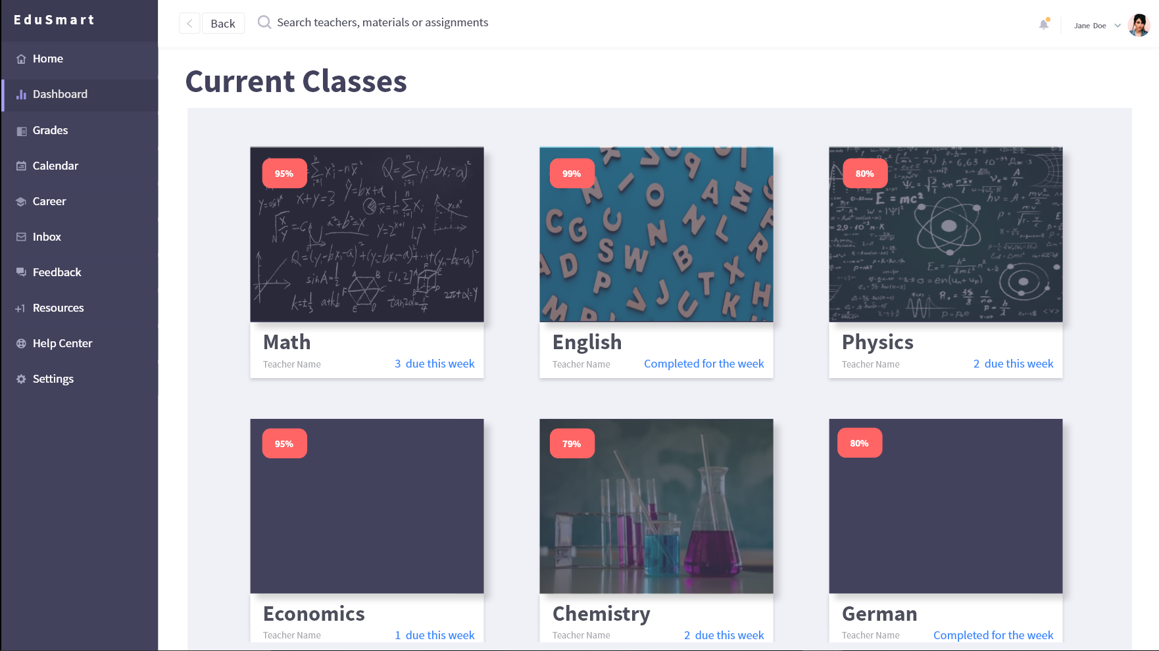

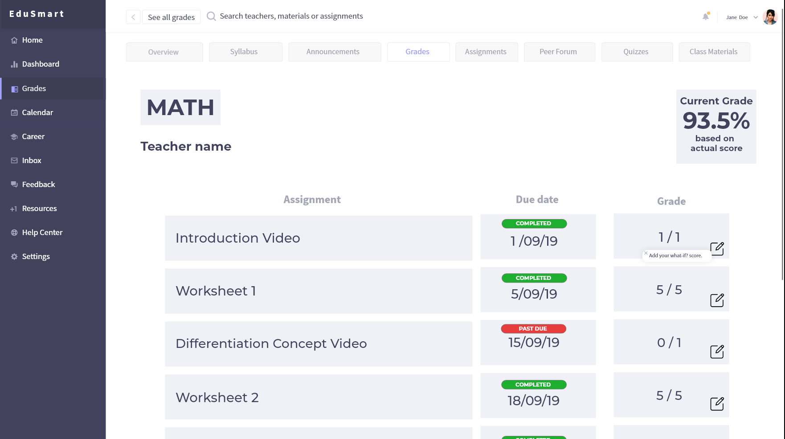

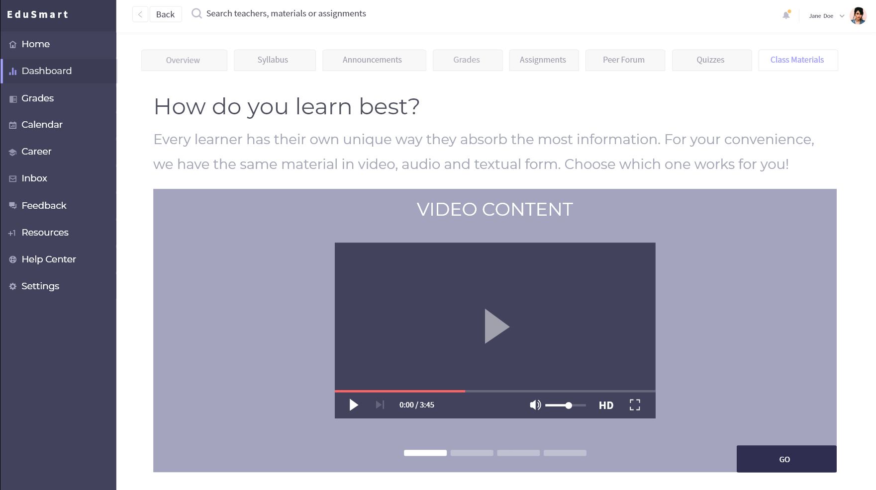

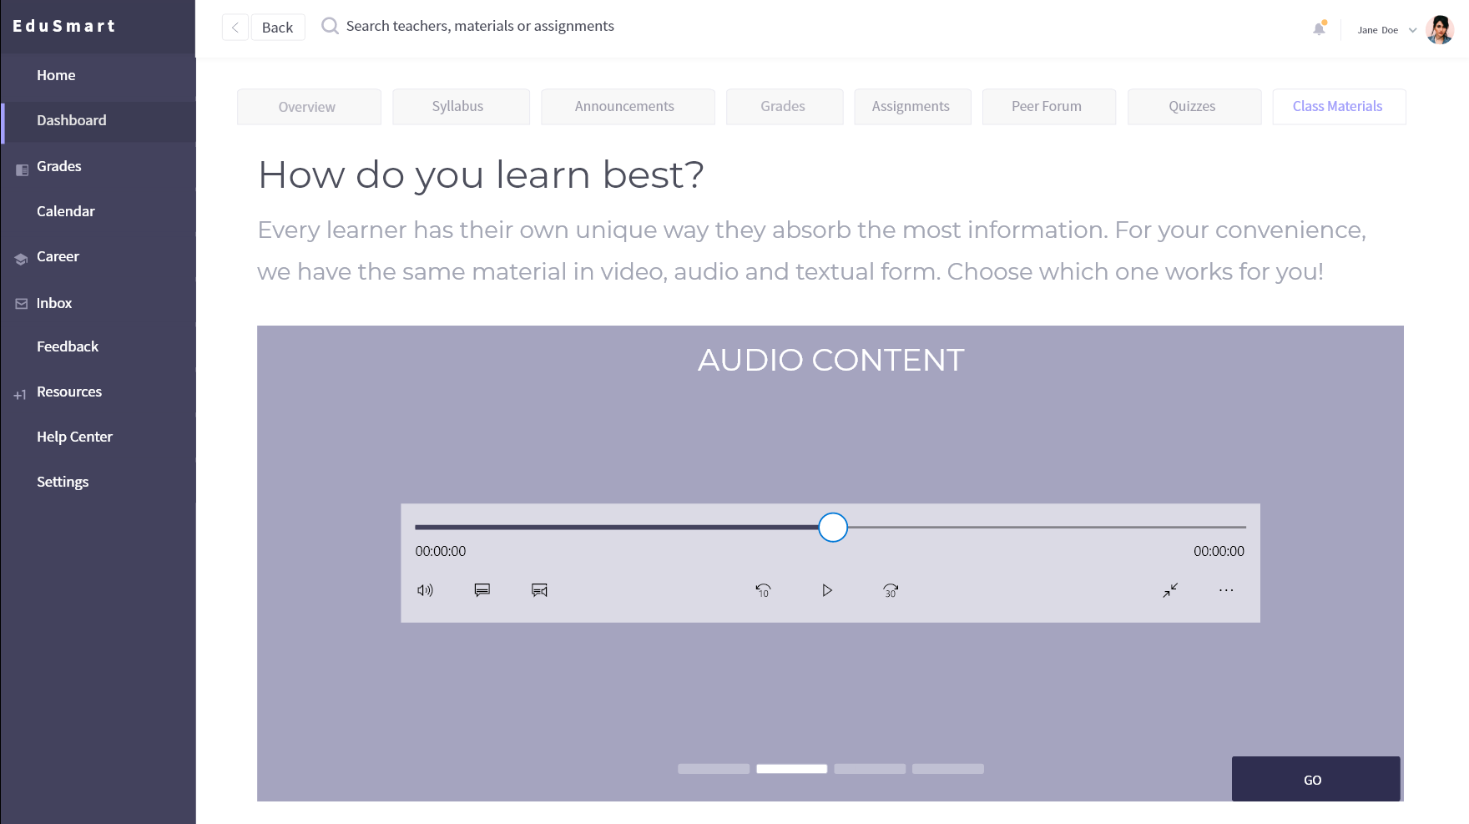

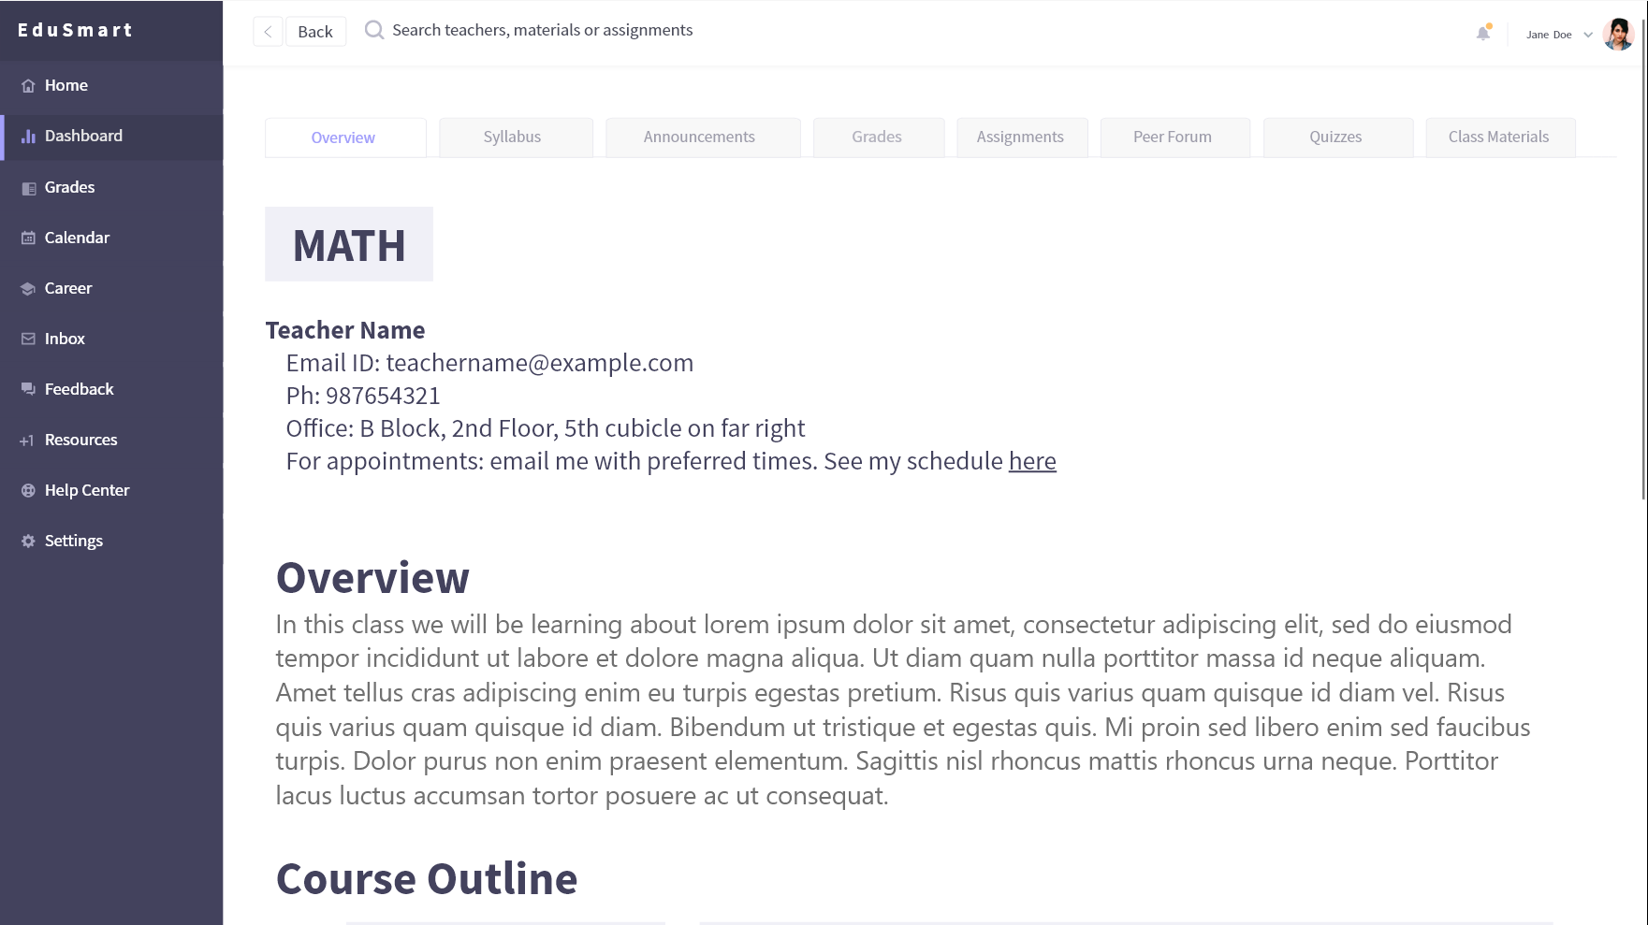

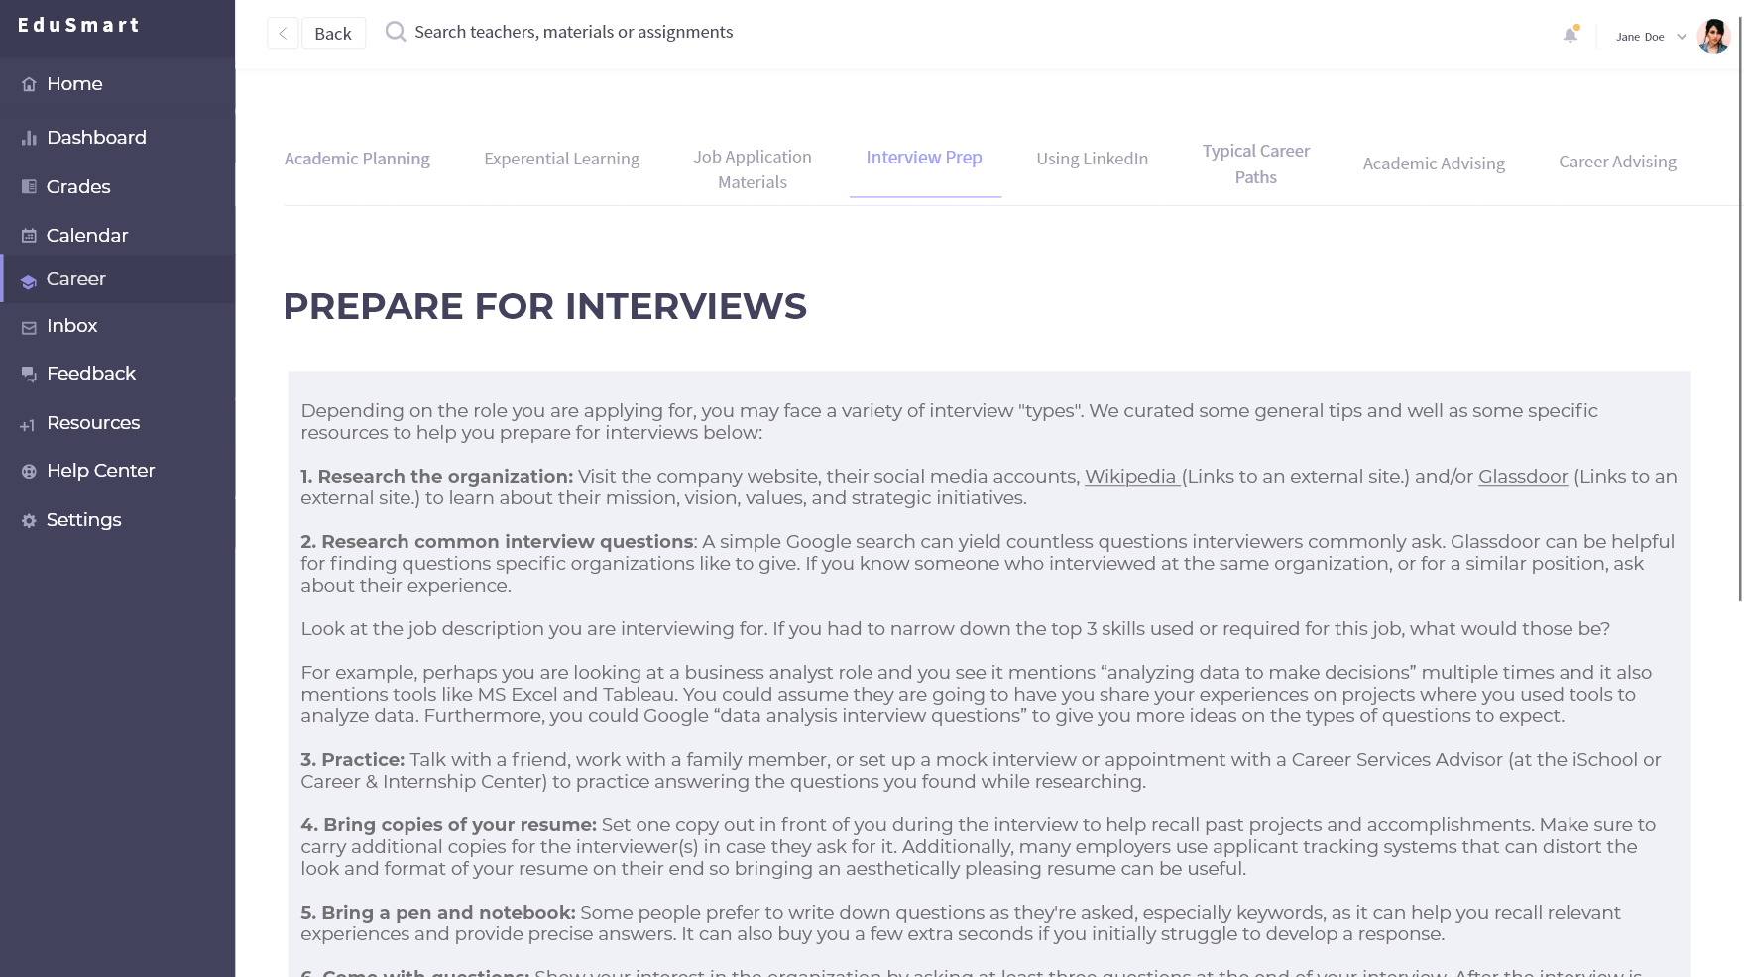



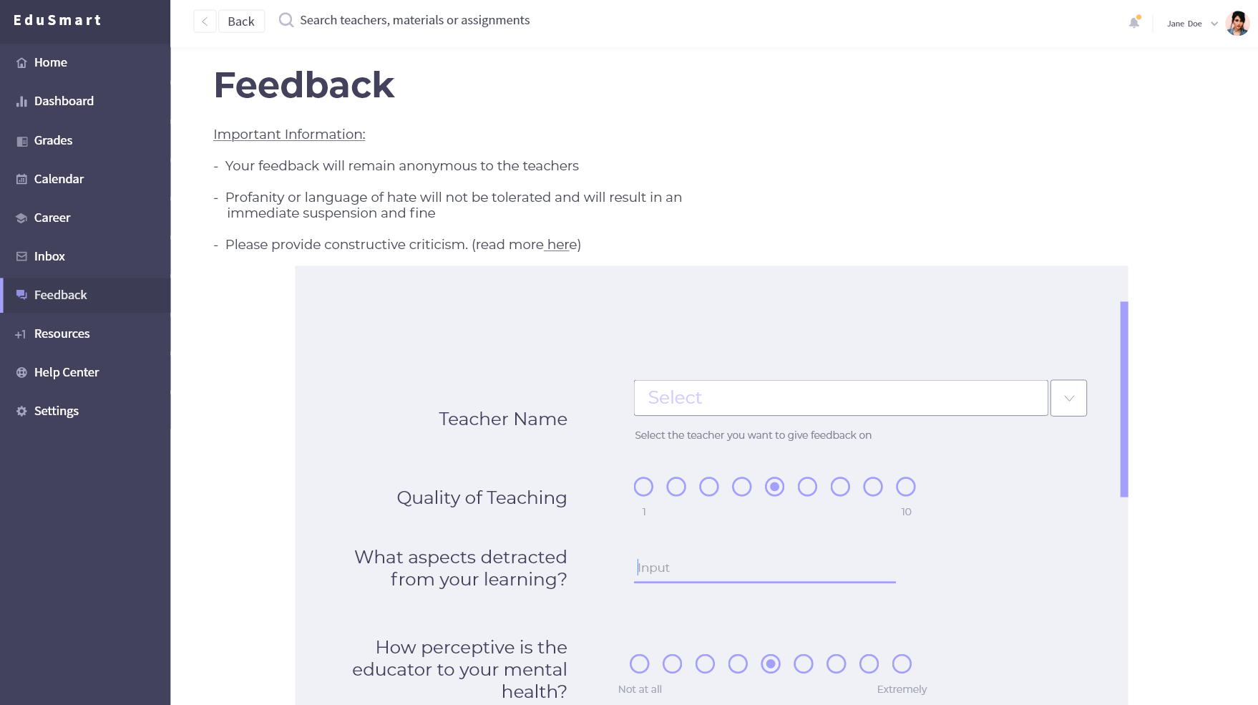

## How can machine learning help this process?

* Can track student progress and problem points to suggest material that could help them.
* Can track techniques in pedagogy and learning that could help research.

# Case study – online education platforms

## Khan Academy

Khan Academy is a not-for-profit educational organization started by Salman Khan in 2008. It provides free short videos on topics ranging from math to finance with step by step problems. It also allows students to track their progress and work on problems in a self-paced manner.

### How did it start?

Salman began by remotely tutoring his cousin. Soon he started making videos and uploading it to YouTube since scheduling video calls became an issue. Not only did his cousin prefer the self-paced lecture, his videos gained traction and were being watched by more people. There was a comment on a calculus video saying, “First time I smiled doing a derivative”. This motivated Salman Khan to leave his job as a hedge fund manager and make provide a free, world-class education to anyone, anywhere, through Khan Academy.

### How does it work?

Students can choose a topic and watch lectures based on it. These lectures are a mix of video and textual content. Thereafter, they can solve problems based on the lecture and “master” the topics by doing a few questions right in a row. This builds on prior knowledge to advance to new ones. Mastery of one topic advances you to master the next one, creating a tree like learning.

### Has it worked?

In Los Altos two fifth grade classrooms and two seventh grade classrooms started to use Khan Academy in their education. The lectures were assigned as homework, which students can watch at their own pace and in their comfort zone. Then, exercises are done in class. Teachers can see the progress of all students across all topics. Blue blocks appear for in progress topics, green blocks appear for mastery of a topic and red blocks appear when a student is stuck.

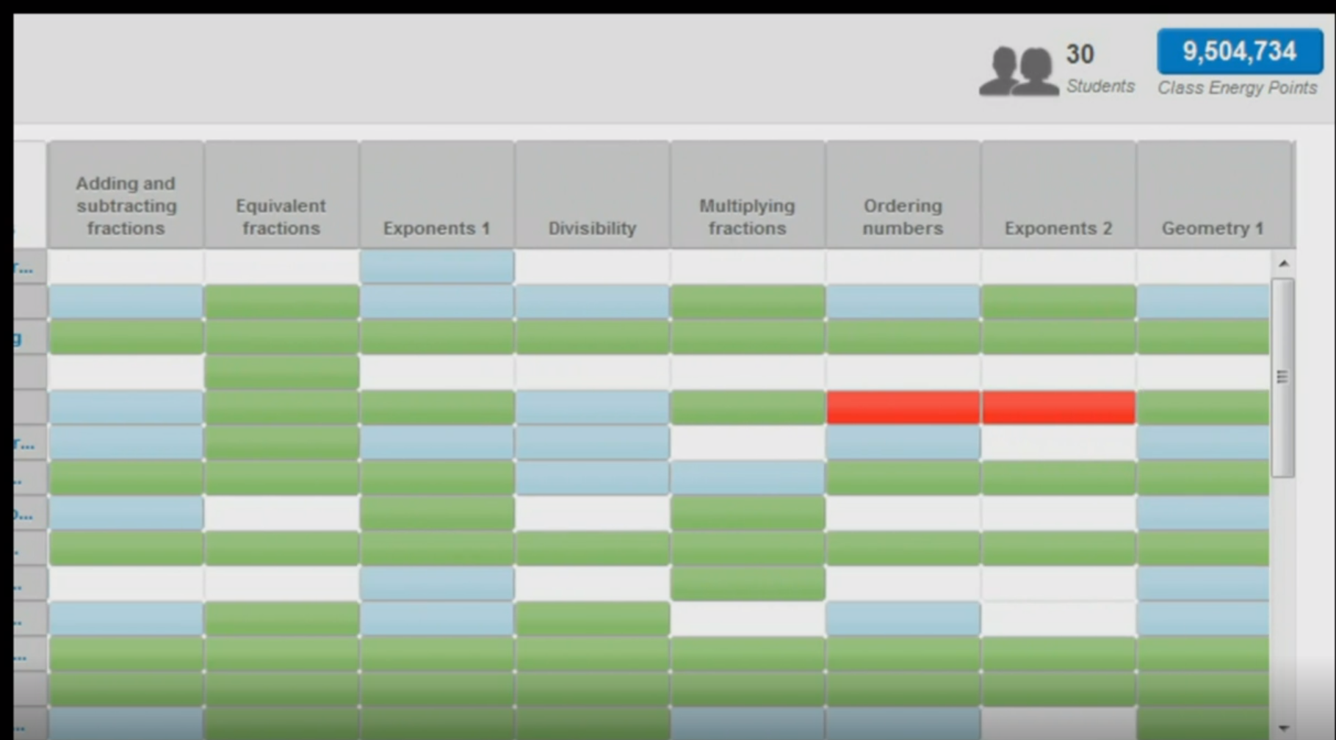

A teacher can now see where and when a student is stuck to offer one on one help. The teacher can also see which problems they got wrong and how much time they spent watching lectures etc.

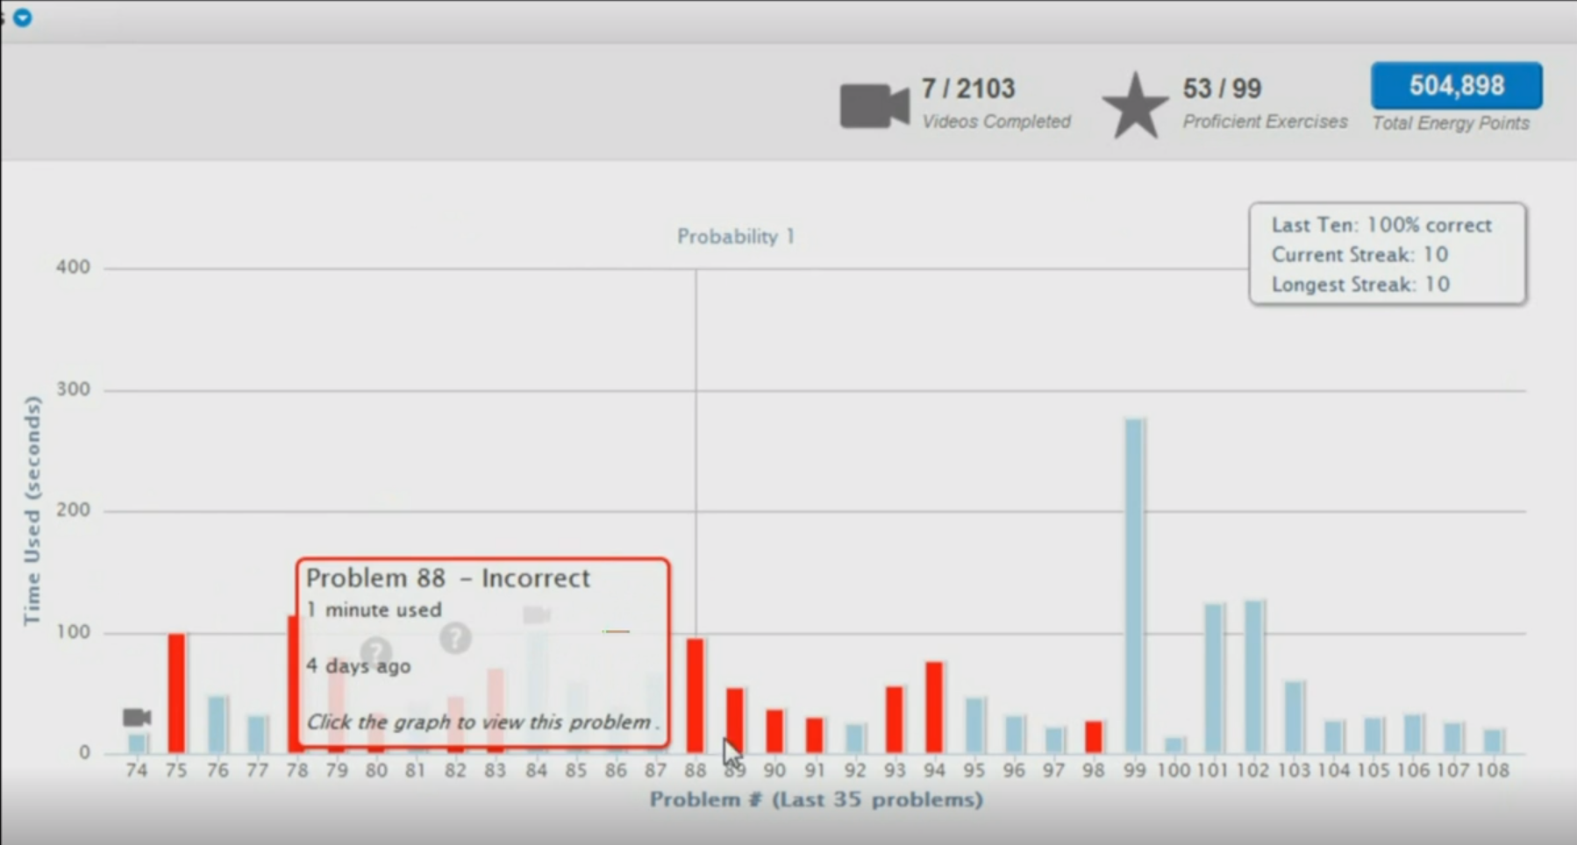

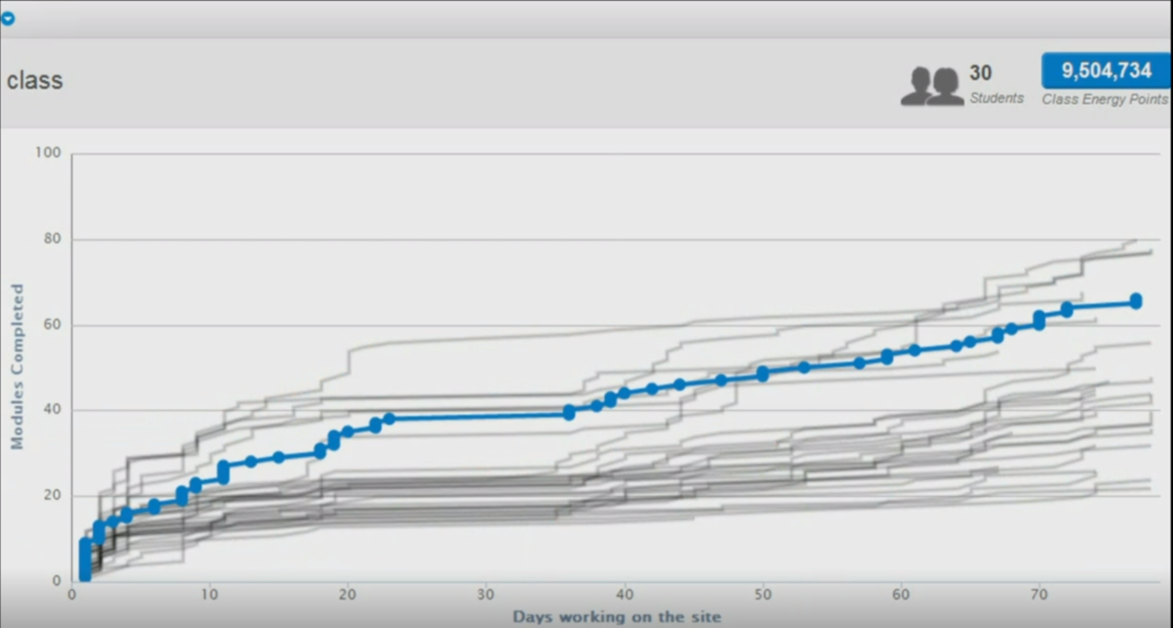

(Khan, 2011)

This has not only changed a teacher’s time from maybe 20% interaction with students to 100%. This also creates a seamless transition between teachers when advancing to a new class. (Wikipedia Contributers, 2019)

Overall, the Khan Academy platform has flipped the classroom for the better, making learning for mastery and not for grades. This has been very helpful to students, their stories can be seen here <https://www.khanacademy.org/stories>.

## EdX

EdX is a non-profit MOOC (Massive Open Online Course) provider. The site hosts university level course material to enhance teaching and learning on college campuses. Additionally, they use the EdX platform to conduct research experiments to learn about pedagogy and the learning process amongst students.

### How does it work?

EdX courses consist of weekly learning sequences. Each learning sequence is composed of short videos interspersed with interactive learning exercises, where students can immediately practice the concepts from the videos. The courses often include tutorial videos that are like small on-campus discussion groups, an online textbook, and an online discussion forum where students can post and review questions and comments to each other and teaching assistants. Where applicable, online laboratories are incorporated into the course. For example, in edX's first MOOC — a circuits and electronics course — students built virtual circuits in an online lab (Wikipedia Contributers, 2019). Courses can also be taken for credit or audit some verified courses. They also offer ‘XSeries Certificates’ for completion of a set of 2-7 courses in a single subject for a price.

### Has it worked?

In addition to educational offerings in higher education, research into learning and distance education by collecting learners' clicks and analyzing the data, as well as collecting demographics from each registrant. Research focuses on improving retention, course completion and learning outcomes in traditional campus courses and online.

EdX has become a platform that helps people follow through with their passion and learn more about skills in the workplace. One such story is of Akshay Kulkarni who went from bad grades and no college education to a job at Microsoft and then an AI startup, all because of edX courses. (Shah, 2016)



# CONCLUSION

For the betterment of the education system in India I propose changing the archaic system currently present by shifting emphasis on rote learning and grades to learning and overall development of children.

On the basis of a feedback form filled by students, parents, educators and potential employers I have identified the major areas to target and change. This includes training teachers in techniques that facilitate learning and being perceptive about why a child is not able to learn, training students in career building techniques, an online platform that can seamlessly integrate communication between students and teachers and lastly, a system that allows meaningful change.

I have also proposed a website that could be used for integration and included case studied on why and how online educations has worked for the betterment of learning.

# FAQ

**Where can I fill out the form to give feedback on my experience as a student, educator, or potential employer?**

The form can be found [here](https://forms.gle/HbGKZ7GTm2ubeJn57). I am always accepting feedback and will make sure to accommodate your feedback in my research!

**Can we actually change the entire system of C.B.S.E that has been in India for decades?**

Admittedly, it is a challenging task. But Amazon Leadership Principles urge us to think big! With Amazons insistence on highest standards I am sure slowly but steadily we can bring real change.

**I am an educator and would like to learn more about how to make the learning process better for students. How can I do that?**

I would recommend doing some reading from credible sources like research papers and well-known publishers. Trying methods, receiving feedback and accommodating it is the best way to evolve as an educator.

**I am unfamiliar with mental health issues and how to deal with them. How can I learn more about that?**

The first step is definitely having an open mind and you’re already there! I recommend reading and watching videos about peoples experience with mental health and actively listening to the impact it has on their lives.

**Will caring about these secondary factors harm student’s education?**

After doing research and being a former student, I assure you that having an all-round development which includes academic and extracurricular activities equally is prosperous to a child’s well being and personality

**How will schools be able to catch up with the syllabus with no homework and self-paced work?**

The goal is to change the system in a way that catching up will not be given as much attention as learning will. The curriculum will be transformed in a way that is comfortable yet sufficiently challenging for students as well teachers.

# Bibliography

Bachelard, G. (1957). *The Poetics of Space.* France: Presses Universitaires de France.

Boudourides, M. (2003). *Constructivism, education, science and technology.* Canadian Journal of Learning and Technology,. Retrieved from http://www.cjlt.ca/index.php/cjlt/article/viewArticle/83/77

Brooks, J., & Brooks, M. (1993). *In Search of Understanding: The Case for Constructivist Classrooms.* Alexandria, VA: Association for Supervision and Curriculum Development.

Bybee, R., Taylor, J., Van Scotter, P., Powell, J., Westbrook, A., & Landes, N. (The BSCS 5E Instructional model: Origins and effectiveness.). *2006.* Retrieved from http://bit.ly/32H0Dnz

*edX*. (n.d.). Retrieved from https://www.edx.org/about-us

Jodi Heckel. (2016, January 22). A green view through a classroom window can improve students’ performance, study finds. *Illinois News Bureau*. Retrieved from https://news.illinois.edu/view/6367/314736

Khan, S. (2011, March). Let's use video to reinvent education. Retrieved from https://www.ted.com/talks/salman_khan_let_s_use_video_to_reinvent_education?language=en

Mintzes, J., Wandersee, J., & Novak, J. (2005). *Teaching Science for Understanding: A human Constructivist View.* Burlignton, MA: Elsevier Academic Press.

Naparstek, N. (2002). *Successful educators : a practical guide for understanding children's learning problems and mental health issues.* Westport: Bergin & Garvey.

Project WET Foundation. (2011). *Project WET Curriculum and Activity Guide, Generation 2.0.* Bozeman, MT: Project WET Foundation.

Prosser, M., & Trigwell, K. (1999). *Understanding Learning and Teaching: The Experience in Higher Education.* Philadelphia: SRHE and Open University Press. Retrieved from http://bit.ly/32LRcnd

Shah, M. (2016, Jan 26). *Akshay Kulkarni: From edX Courses to a Job at Microsoft*. Retrieved from edX: https://blog.edx.org/akshay-kulkarni-from-edx-courses-to-a-job-at-microsoft

Wikipedia Contributers. (2019, July 14). *EdX*. (Wikipedia, The Free Encyclopedia.) Retrieved from https://en.wikipedia.org/wiki/EdX

Wikipedia Contributers. (2019, June 29). *Khan Academy*. Retrieved from Wikipedia, The Free Encyclopedia: https://en.wikipedia.org/w/index.php?title=Khan_Academy&oldid=903807174

Zeidner, M. (2009). *What We Know about Emotional Inelligence How It Affects Learning, Work and Relationships, and Our Mental Health.* MIT Press.

# Appendices

## [Final form](https://docs.google.com/forms/d/e/1FAIpQLSfyy0H_6IUImaG_pXHqgCS6ZTDI3rqwSnA-cNntxOpRMM_q9g/viewform?usp=pp_url)

## Brainstorming questions

## 

## Response numbers

|  |  |
| --- | --- |
| Student response | 37 |
| Parent Response | 5 |
| Educator Response | 9 |
| Potential Employer response | 4 |

## 

## Response statistic: Effects on mental health

(1 – Deteriorated, 5- Flourished)

### C:\Users\Saasha\AppData\Local\Microsoft\Windows\INetCache\Content.MSO\15487800.tmp

## Response statistics

### C:\Users\Saasha\AppData\Local\Microsoft\Windows\INetCache\Content.MSO\58109E0E.tmp

## Feedback brainstorming

### 

## Research + Feedback Brainstorming

## 